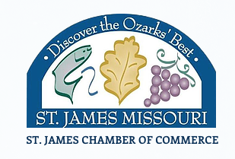

St James Grape & Fall Festival
Lil Royal Court
Application Deadline June 30, 2021

Little Mr. & Miss have been a part of the Grape & Fall Festival Pageant since the mid 1950’s. They have served several roles over those years. In 2017 they became their own pageant within the pageant. As of 2021 we are returning to our roots. This year Little Mr. & Miss will be recognized as the Royal Court for our Queen. Each little Mr. or Miss will be assigned to a Queen candidate and will NOT be judged. Each of these young royals will be crowned and will have several roles in the pageant.
We are also encouraging more recognition for our local businesses and community. Each Little Mr. & Miss will need a $50 sponsor. They will receive a sash with their sponsor’s name to be worn during the pageant and Grape & Fall Festival. Sponsors can be a local business, grandparents, or any family member wanting to support our local community members.

Little Mr. & Miss Candidates will:
- Perform in a group number
- Will participate in the formal attire walk - wearing their “Sunday Best” (formal dress not required)
Qualifications:
- Child must be at least 5 years old AND must be going into Kindergarten the 2021/2022 school year.
- Child must be enrolled in the St. James School District OR if home-schooled, live inside the St James School District.
- Sponsorship check should be made out to: St. James Chamber of Commerce
- Sponsorship checks are due at first pageant practice.

St James Grape & Fall Festival
Lil Royal Court
Application Deadline June 30, 2021

Childs Name: ___________________________________ Birthday________________________
Parent/Guardian: _______________________________________________________________
Home Address: _________________________________________________________________
Phone Numbers :_________________________( Cell) ___________________________(Home)
Parent/Guardian Email: __________________________________________________________
Short Bio to be read on stage during formal walk: (please be sure to include family information, favorite activity, favorite color, what they want to be when they grow up, etc.) ____________________________________________________________________________________________________________________________________________________________________________________________________________________________________________________________________________________________________________________________________________________________________________________________________________________________________________________________________________________

Hero: _________________________________________________________________________

Sponsor: _____________________________________________________________________________

